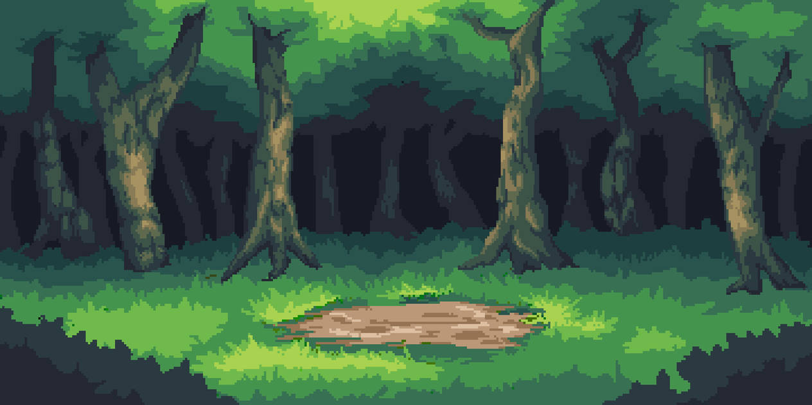

Combo Forest

By Pascariu Catalin

Description 3

Characters 4

Classes 4

Knight 4

Thief 6

Mage 7

Controls 9

World 9

Combat 9

Camera 11

World 11

Combat 11

Environment 12

Theme 12

The Forest 12

Enemies 12

Goblin 14

Goblin Mage 14

Zombie Knight 15

Ork 15

Assassin 16

Ghost 16

Demon 17

Demon Lord 17

Trainer’s camp 18

Shopkeeper 18

Blacksmith 19

Trainer 20

Combat 20

Rules 20

Win & Loss 20

Equipment 21

Abilities 21

Combos 21

Economy 22

Interface 23

Menu 23

UI 23

Select UI 23

Map UI 24

Fight UI 25

Player 26

Graphics and Sound 27

Graphics 27

Sound 28



# Description

* Turned Based Fighting Lateral View
* This game takes place in medieval era where the player can choose a class (Knight, Thief, Mage) then will need to traverse a forest to eliminate the monster that threatens the peace of the palace.

**Game start**

* The player receives different abilities depending the class that he chose then he will have a 1v1 fight with the first enemy, this has the role to teach the player how to play the game
* Combat description:

1. A character enters the in offensive mode and the other enters in defensive mode
2. The character in offensive mode prepares his attacks and the character in defensive mode prepares his defence, after that the damage is dealt and the modes are reversed.
3. Both the player and the NPC have a set number of ability slots, if 2 abilities are put inside a slot then they transform in a new ability “combo”

* After the player defeats the first enemy he can chose between 2 roads, that can go 3 different ways:

1. A merchant that will sell weapons/armor
2. A trainer that will teach new abilities at a price
3. Another enemy

# Characters

All characters will have have three slots for equipment, changing the equipment will only influence the stats of the character and not the aspect of the character.

Some characters may be missing armor, attack weapon or shield weapon.

Equipment and Abilities can be upgraded by the player increasing their stats.

Equipment can be upgraded at the blacksmith and the Abilities at the Trainer

For ease of use the characters, equipment and abilities will use following table and will use the following equation to calculate the damage.

**Total damage = (Attack/(1+Armor/Modifier))**

* Attack = Total attack of the player
* Armor = Total armor of the target
* Modifier = Can be used to change the total damage received the higher @ the higher the damage received by the target, for now it will be set at 100.

For more information about Equipment go to **TurnBased Fighting_Table Character section & TurnBased Fighting_Table Start section.**

## Classes

Currently there are 3 classes **Knight**, **Thief**, **Mage** with every class specialized in defence, attack or both.

### Knight

**Design**

The character looks like a typical european knight encased in armor with a sword in his right arm used for attacks and a shield in his left arm used to defend.

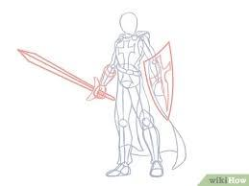 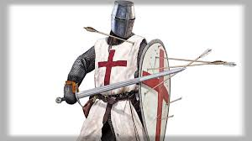

**Stats**

The knight is specialized in defence, using his shield and armor to resist even in front of even the most powerful enemies, but he has a relatively low attack force. While using combos is advised the player can progress a good portion without using the best combos or even not using them at all.

* Name: Knight
* Class: Knight
* Health: 30
* Attack: 10
* Armor: 25
* Attack_Slot: 2
* Defend_Slot: 4
* Moves_Total: 6
* Initiative: 14

|  |  |  |  |  |  |  |  |
| --- | --- | --- | --- | --- | --- | --- | --- |
| **Starting Equipment** | | | | | | | |
| **Name** | **Class** | **Type** | **Health** | **Attack** | **Armor** | **Initiative** | **Level** |
|  |  |  |  |  |  |  |  |
| Beginner armor | Knight | Armor | 20 | 0 | 20 | 0 | 1 |
| Beginner sword | Knight | Weapon | 0 | 15 | 0 | 5 | 1 |
| Beginner shield | Knight | Shield | 10 | 0 | 15 | 2 | 1 |

### Thief

**Design**

The thief has black tattered clothing, and a mask that hides his nose and mouth, he is equipped with a small shield in his left arm and a dagger in his right arm and a crossbow (counts as a ability) partially visible on his back used for sneak attacks.

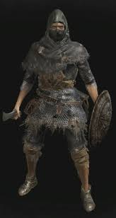 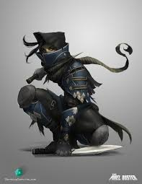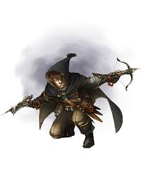

**Stats**

The thief is a more balanced class with good attack and defence, having equal attack and defence stats.

* Name: Thief
* Class: Thief
* Health: 25
* Attack: 15
* Armor: 15
* Attack_Slot: 3
* Defend_Slot: 3
* Moves_Total: 6
* Initiative: 18

|  |  |  |  |  |  |  |  |
| --- | --- | --- | --- | --- | --- | --- | --- |
| **Starting Equipment** | | | | | | | |
| **Name** | **Class** | **Type** | **Health** | **Attack** | **Armor** | **Initiative** | **Level** |
|  |  |  |  |  |  |  |  |
| Beginner cloak | Thief | Armor | 10 | 0 | 10 | 0 | 1 |
| Beginner dagger | Thief | Weapon | 0 | 20 | 0 | 5 | 1 |
| Beginner small shield | Thief | Shield | 10 | 0 | 10 | 5 | 1 |

### Mage

**Design**

The mage has a long robe, a staff and a long beard. While the mage does not have a physical shield, he can create a protective barrier using his magic. To show his magic the character is in a permanent state of floating, only touching the ground when he is defeated.

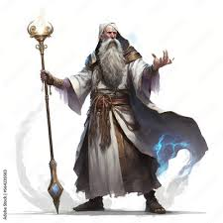 

**Stats**

The mage has good attack but low defence. He specializes in explosive damage. Mage can only use armor and attack equipment.

* Name: Mage
* Class: Mage
* Health: 20
* Attack: 20
* Armor: 10
* Attack_Slot: 4
* Defend_Slot: 2
* Moves_Total: 6
* Initiative: 20

|  |  |  |  |  |  |  |  |
| --- | --- | --- | --- | --- | --- | --- | --- |
| **Starting Equipment** | | | | | | | |
| **Name** | **Class** | **Type** | **Health** | **Attack** | **Armor** | **Initiative** | **Level** |
|  |  |  |  |  |  |  |  |
| Beginner robe | Mage | Armor | 10 | 0 | 10 | 0 | 1 |
| Beginner staff | Mage | Weapon | 5 | 30 | 0 | 15 | 1 |

## Controls

The player has two ways to control the character depending if he is in the world or in combat.

### World

While in the world, the player will look at a maze like map, where the player can move the character up/down/left/right following the road un interact with the interest points

W - Up

A - Left

S - Down

D - Right

Space - Interact

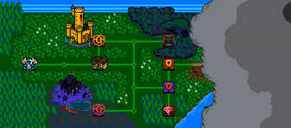

### Combat

While in combat the player will use the mouse to select the moves needed to end the fight.

The player needs to manage and choose his moves. Every move has the next characteristics:

- can be used to attack/defend or both depending the move

- can be used only once per round

- while a move can be used only once per round the player can equip 2 or more identical moves and use them independently)

- may need multiple round before can be used (under every move are up to 4 points, every round a point is filled and when all points are filled the move can be used, after use all the points are depleted)

- every move can be a **Main** (must be used first, does not make a combo with another main move, but will make a combo with one or more support moves).

The player starts the combat with 5 abilities in total 2 for defense and 3 for attack where one needs 2 turns before it can be used, and 20 health. And a enemy with 3 abilities in total 1 for defense and 2 for attack where one needs 3 turns before it can be used, and 15 health.

At the start of the round the entity with the higher Initiative will attack first. (Let’s say the player attacks first)

**First round attack:** The player will combine his attack moves, then the enemy chooses and combines his defense moves, after that the enemy receives 3 damage (12 H left)

**First round defense:** The enemy chooses his attack moves, then the player chooses his defense moves, after that the player receives 4 damage. (16 H left)

**Second round attack:** The player can now attack with the ability that takes 2 turns (to charge) and the enemy defends, enemy receives 5 damage. (7 H left)

**Second round defend:** The enemy attacks and the player defends, the player receives 4 damage (12 H left)

**Third round attack:** The player attacks and the enemy defends, the enemy takes 3 damage. (4 H left)

**Third round defend:** The enemy can use his ability (3 turns to charge), and the player defends, the player takes 7 damage. (5 H left)

**Forth round attack:** The player can use his charge move again to attack, the enemy defends, the enemy takes 5 damage (0 H – the fight ends)

# Camera

The camera presents the world in two ways: World and Combat

## World

While in world camera presents a top-down perspective where the player can see the map. When the player moves between maps a transition in present .

## Combat

In combat camera is static and presents a lateral view of the scene.

Special effects:

- Camera will shake slightly

# Environment

## Theme

The overall theme of the level is that of a forest, the background will be a thick foliage of trees, small bushes and flowers.

## The Forest

Level selector is top-down map where the player can move the character above every level, if a level is completed then he can move freely above it, if the level is not completed then he needs to fight.

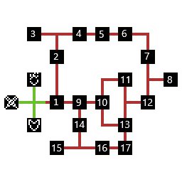

### Enemies

Enemies will follow a simple pattern switching between attack and defence.

For more information about Equipment go to **TurnBased Fighting_Table Enemies section**.

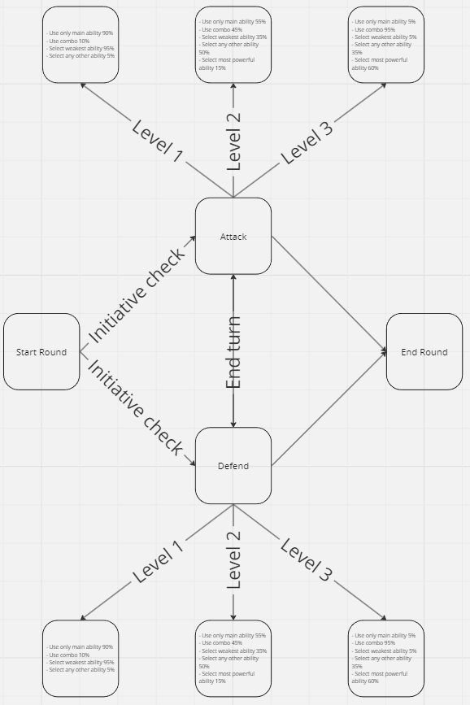

#### Goblin

**Design**

The goblin is a small humanoid with green skin and a simple cloth covering his body, he caries a small knife in his left hand and a wood plank in his right hand used as a shield.

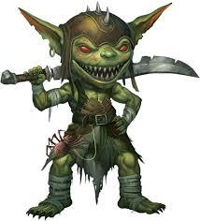

#### Goblin Mage

**Design**

The goblin mage is a small humanoid with green skin, a dirty and tattered robe, and a stick with a blue light at the end.

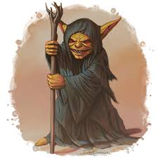

#### Zombie Knight

**Design**

A humanoid with heavy damaged armor, decaying flesh can be seen where the armor is damaged. Zombie also caries a shield cut in half in his left hand and a sword in his left hand.

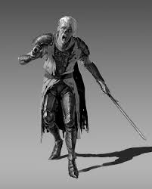

#### Ork

**Design**

A large humanoid with muddy green skin and a armor made from tree bark, caries a large trunk used as a weapon.

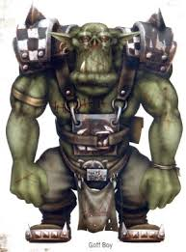

#### Assassin

**Design**

A humanoid covered in dark clothes caring a dagger in his left hand.

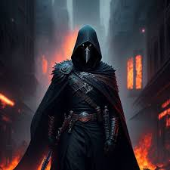

#### Ghost

**Design**

The ghost is a spirit with few human characteristics, but with a light blue body and a small ball of fire in his right hand.

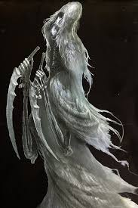

#### Demon

**Design**

A humanoid with red skin, presents a set of large wings on his back and large horns on his head, presents large claws on his hands used for attack.

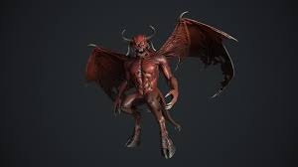

#### Demon Lord

**Design**

Similar with the demon presents red skin, wings and horns, also has a red armor covering his body and a large staff ornate with a claw at the end holding a big blue orb.

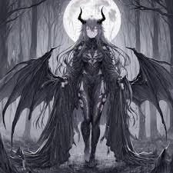

## Trainer’s camp

The town will follow a similar layout to the forest the only difference is that if the player interacts with the shopkeeper or the blacksmith will open a interface where the player can buy new equipment / abilities or upgrade them.

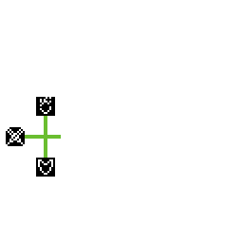

### Shopkeeper

Once the player interacts with the Shoopkeeper a new UI page will open where the player can upgrade his abilities. Abilities present are only those the player has unlocked already, once a ability is fully upgraded it will disappear from the list.

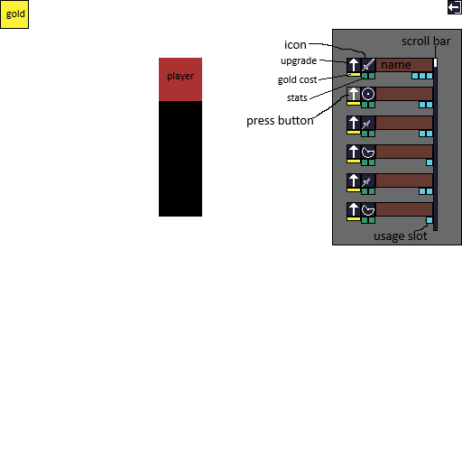

Using the image above the player has access to the next information's:

* **Gold:** Total gold that the player poses
* **Player:** A icon representing the player
* **Icon:** Represents the type of the ability
* **Upgrade:** Button witch will upgrade the ability once it is pressed
* **Gold cost:** The cost for the upgrade
* **Stats:** Show the stats once the ability is upgraded
* **Usage slot:** Shows the number of turns until the ability can be used
* **Name:** The name of the skill
* **Press button:** The button will change colors when it is pressed, also the button will automatically change to this color when the player does not have enough gold to upgrade.
* **Exit:** A button for the player to exit from this menu

### Blacksmith

Once the player interacts with the Shoopkeeper a new UI page will open where the player can upgrade his equipment and buy new ones. Once a equipment is fully upgraded it will disappear from the list, intermediary and master level equipment are present and can be purchased from the shop from the beginning. The same button that the player uses to upgrade is used to buy the next set of equipment, the icon will be different.

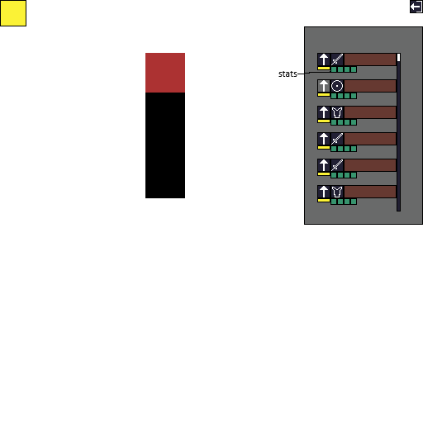

Using the image above the player has access to the same information as the shoopkeeper with the difference that

* **Stats:** Show the stats once the armor is upgraded
* **Usage slot:** Missing from equipment

### Trainer

The trainer will mirror any enemy that the player chooses to fight, copying the equipment, abilities and level. The trainer uses the same UI as the normal enemies.

# Combat

## Rules

Combat is formed from turns and actions, a turn has two actions: attack actions and a defence actions determined by the total initiative.

The side with the hies initiative will start with the attack action while the other will have the defence initiative, they will chose their abilities and the action will end, after that the next action starts where the roles are reversed and the attacking party needs to defend and the defend party needs to attack, after this action ends the turn ends, every ability receives one usage slot and the circle repeats.

When the combat starts all abilities receives one usage slot.

Rules:

* Highest initiative attacks first
* Roles are reversed after the first action
* Any ability can be used only once during the fight
* All abilities must start with a Main ability
* Support abilities can be used only after main abilities
* Total damage/armor is calculated by using: Player stat + equipment stat + Main ability stat + secondary abilities stat * 1.5
* Any Support abilities will empower the first attack using (secondary abilities stat * 1.5)

## Win & Loss

**Win**

After a win the player will receive the gold and the ability assigned to that level. If a player is forced to repeat a level, no additional gold will be given to the player. The player can now progress to the next level.

**Loss**

After a loss the player returns to the Trainer, and the level closest to the one where he is defeated will be made available again, the player needs to fight in this level before proceeding in the game, the ability corresponding with that level will not be impacted.

## Equipment

The only resources that the player needs to manage are Gold (used to upgrade equipment and abilities) and Equipment witch offer greater health, attack, armor and initiative.

Equipment is split in 3 categories: **Armor**, **Attack**, **Defend** every character uses only one item of each category, some characters(such as the Mage) may miss a piece of equipment.

For more information about Equipment go to **TurnBasedFighting_ Table Equipment section.**

## Abilities

Abilities can be unlocked after defeating a enemy or are given to the player at the beginning of the game. Abilities can be upgraded at the Shopkeeper using Gold.

**Abilities** can be categorized in:

* Attack Main
* Attack Support
* Defend Main
* Defend Support

They also have a number of rounds until it can be used again.

For more information about Equipment go to **TurnBasedFighting_ Table Abilities section**.

## Combos

To perform a combo the player needs to use first a main ability then one ore more secondary abilities, their stats will be calculated using **Player stat + equipment stat + Main ability stat + secondary abilities stat * 1.5**

# Economy

The player will gain gold after every fight, the gold can be obtain only once per fight after the player defeats the enemy for the first time, after that the player will nor receive any gold if he fights again.

The gold will be used to buy/upgrade the equipment and to upgrade abilities.

For a full upgrade the player needs ~2750 gold, fighting all enemies before the final boss the player will gather a total of **3000 gold** witch will permit the player to fully prepare for the fight.

# Interface

## Menu

After opening the game the user is presented with the main menu, from where the player has the next options:

* New game: Used to start a new game
* Continue: Will continue the progress made by the player
* Exit: Will exit from the game

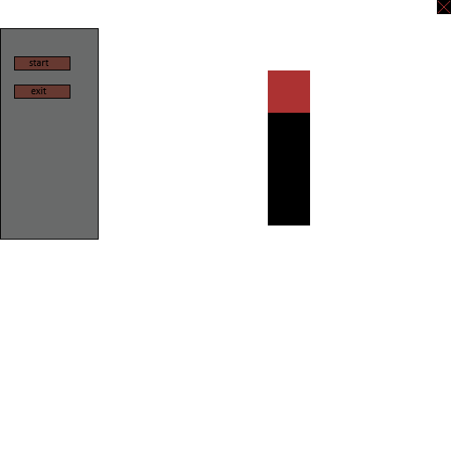

## UI

### Select UI

After selecting New game the player is presented with 3 options between Knight, Thief and Mage. To select a champion he just needs to hover above them and a green arrow will point to the corresponding option, and then the player needs to click on it.

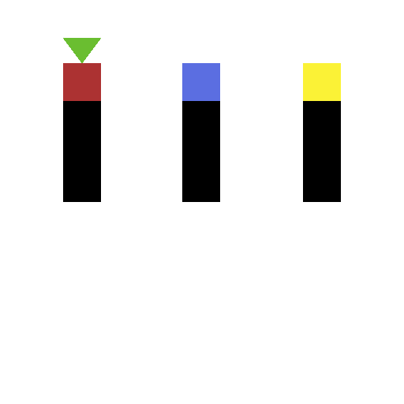

### Map UI

While in the main map the player can see the gold, a button to exit to the menu and:

* Player menu:Witch opens the character page where the player can select new abilities and equipment.
* After wining a fight the player is presented with the ability unlocked and the gold received, this stays on the screen for 3 second and then fades away, it is present only once after defeating the enemy for the first time, applies for every enemy.
* Exit button in top-right that will send the player to the menu

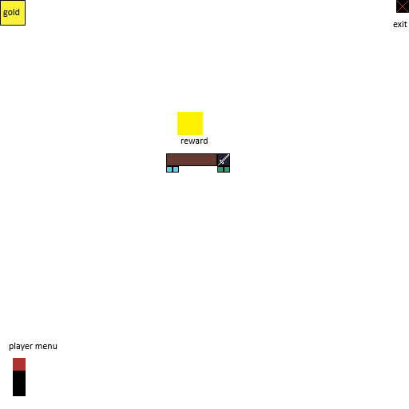

### Fight UI

During the fight the player has access to a large pool of information's such as:

* Gold: The gold that it is in the player inventory
* Mode: It shows what type of moves can be used by the player, after the attack ends the mode will change icons.
* Health: Shows the health of the player and the enemy, it will drop during the fight.
* Used skills: It shows the number of attack slots the player has and once a ability is selected the slot will get a red cross showing that it is in use, slots used for the defend will be grayed out during the attack turn, once the turns are reversed the UI will follow with gray attack icons and red cross for the defend moves used.
* Skill name: The name of the skill.
* Skill icon: Shows what turn and type the ability is, with different icons for each one:
  + Sword: Attack main
  + Broken sword: Attack support
  + Shield Defend main
  + Broken shield: Defend support

Gray out rules:

* When a ability can not be used this turn (ex: defence ability on attack turn)
* After a ability was used
* Player can not see what abilities are gray out for the enemies

After a ability is used if the player presses on it again then he can remove said ability from the combo

* Usage slot: Shows the number of turns until the ability can be used, slots start completely empty and fill from one slot every round from left to right, enemies will mirror this behavior.
* Turn: Shows the current turn number
* Exit: The player can leave the fight at any time
* Go: After the player thinks he wants the fight to start he needs to press the go button

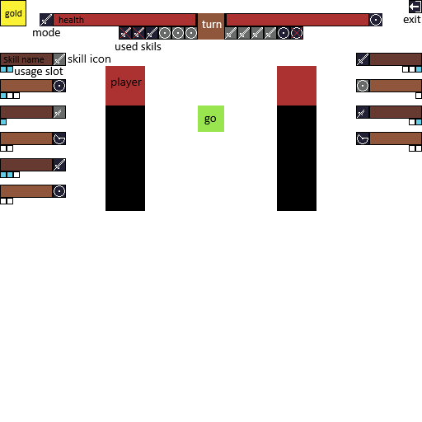

## Player

The player menu is the place where the player can change abilities and equipment. He can change only between the abilities/equipment that he has discovered, to change he needs to drag and drop selected abilities/equipment in their slot.

For class specific restrictions the slots will have a gray symbol in the empty slot to mark what type of ability can be used.

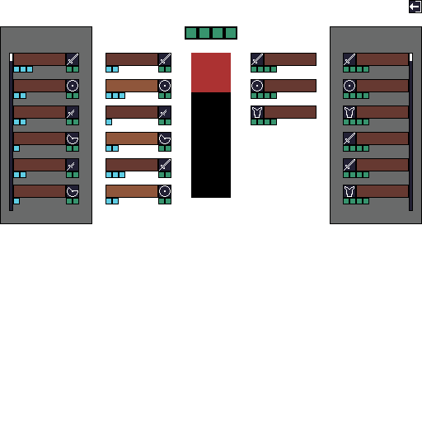

# Graphics and Sound

## Graphics

The game will have 2 main backgrounds:

* A simple green background witch is displayed behind the map, will also contain small depictions of trees and shrubs scattered at the edges of the map.
* A more detailed background depicting a dark forest with tall trees and small shrubs creating a sense of confinement.

Visual Effects:

* A small flash of light - During the fight when the attack happens (any side)
* Enter from left - After the player selects a level the fighting screen will rapidly enter from the left towards the right side of the screen
* Exit towards the left - After the player wins a fight the level will disappear on the left side of the screen
* Crumbling effect - After the player is defeated by a enemy the fighting screen will crumble and fall down
* Slide off effect - After a enemy / the player is defeated he will fall down from the screen

## Sound

Sound effects will be played following the next events:

* Slow music while in map mode
* Alert music while in attack mode
* Move while on map mode
* Enter level
* Attack
* Win level
* Lose level
* Upgrade/Buy ability/equipment